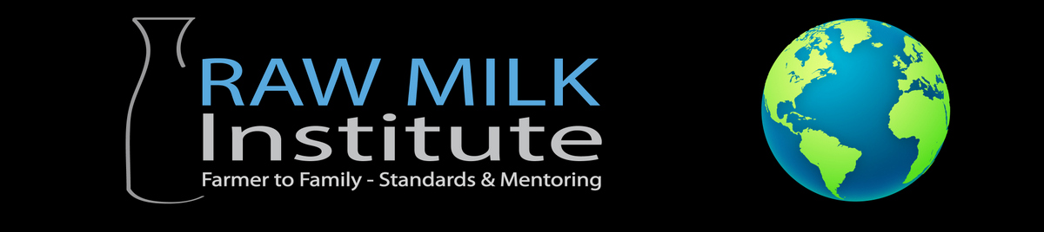
Listed Farmer Annual Checklist

The purpose of this checklist is to help RAWMI Listed Farmers ensure that the conditions and processes on their farm are maintained such that they will continue to produce low-risk raw milk. The checklist should be used as a way to verify the integrity of the milk production and handling processes.

Instructions for RAWMI Listed Farmers:
Once per year, fill out the following checklist. This checklist is not intended to be used as a trivial step. Rather, this checklist is designed to give you a chance to think about your overall operation to make sure it has been optimized for the production of safe raw milk. RAWMI is here to help you, so feel free to contact us with any questions or concerns.

Farm Name:__________________________ Date: __________________________

Item | Notes | Completed?
PRODUCTION

How many raw milk gallons do you estimate that you produced in the last year?
Do you produce other dairy products, such as kefir, butter, yogurt, etc?
How many animals and of what type are you currently milking?
FARM ENVIRONMENT

Water testing has been performed and meets standards
Have there been any significant changes to your farm in the last year? For instance:
- Have you added new animals to your farm?
- Walk the pastures and note forage quality. Consider soil sampling and testing to see if soil fertility needs adjustment.
- Have you implemented new machines or technologies on your farm?
- Have you made changes to the way you collect or handle raw milk?

Item | Notes | Completed?
GUIDING DOCUMENTS AND DATA

Review and update your Risk Assessment and Management Plan (RAMP) | Send a copy of your updated RAMP to RAWMI for review and to be uploaded to your listing area on the RAWMI website
Review and update your Standard Sanitary Operating Procedures (SSOP) to reflect current practices | Send a copy of your updated SSOP to RAWMI for review and to be uploaded to your listing area on the RAWMI website
Review and update your Critical Control Points (CCP) to reflect current practices | Send a copy of your updated CCP to RAWMI for review and to be uploaded to your listing area on the RAWMI website
Review your coliform and SPC test data for the last year, seeking to understand any trends in the data that may reflect the need for changes to your process
Review your listing on the RAWMI website | Send any updates for your listing to the RAWMI Secretary
Review your own website to make sure it is up-to-date and accurate.
HERD HEALTH

Did farm conduct annual TB testing on herd?
Are new hire employees trained on the animal welfare, herd health, common cattle diagnosis prior to starting to work with cows?
MILK PARLOR

Is the farm staff regular inspecting milk claw inflations (liners), milk claw window gaskets and replacing as needed?
Is the farm staff regularly inspecting the “Milk sock filters” or other single use filters to verify clean milk?
Is the farm staff regularly inspecting and changing in-line gaskets, milk hoses, silo gaskets, and other fittings and changing as required?
Is the farm staff regularly inspecting the “fresh air filter” on the vacuum line and servicing pulsators and air hose?
Is the farm staff regularly verifying that the Cleaning-In-Place (CIP) “slug” is cleaning the receiver and trap from any biofilms?

Item | Notes | Completed?
PROCESSING

Is the filling system cleaned after every bottling?
Is the CIP temperature recorded and verified to be above 140 degrees F? Are adequate detergent and acid sanitizer used and verified?
Do the processing staff use PPE (hair nets, gloves, aprons) during processing?
Are there flies or rodents in the processing area and systems to prevent?
DISTRIBUTION/SALES

Review complaint log and confirm all customer feedback has been addressed, resolved, or a plan of action is in place
Are there any notes or updates you would like to share with the RAWMI board or Listed Farmers?

