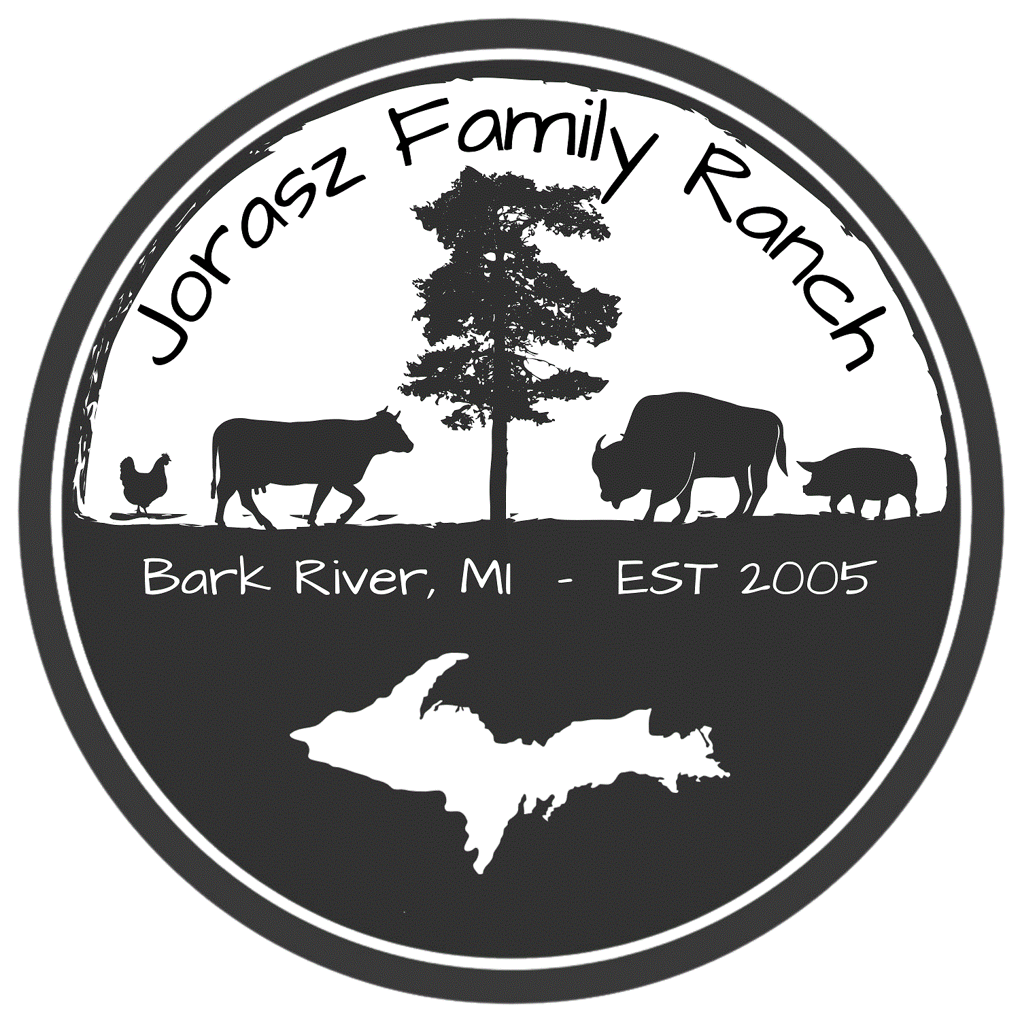
Jorasz Family Ranch LLC
Bark River, MI 49807
(906)723-3135

Critical Control Points

Farm Conditions
- Well water verified annually to be free of coliform bacteria.
Should well water testing indicate the presence of coliform bacteria, milk bottling will cease pending remediation.
Well will be sanitized and the point of contamination be identified. Well water will be retested and verified to be coliform free prior to resuming milk bottling and distribution.

Testing Protocol and Results
- Assure testing is completed, compliant with RAWMI Common Standards, and available for review.
- Testing to be completed monthly
- Test results emailed to RAWMI by the 25th of each month.
- If bacteria results ever rise above the RAWMI standard farmer then contacts RAWMI and/or another, RAWMI listed member to consult and determine cause and re-test until conforming test result is achieved.

