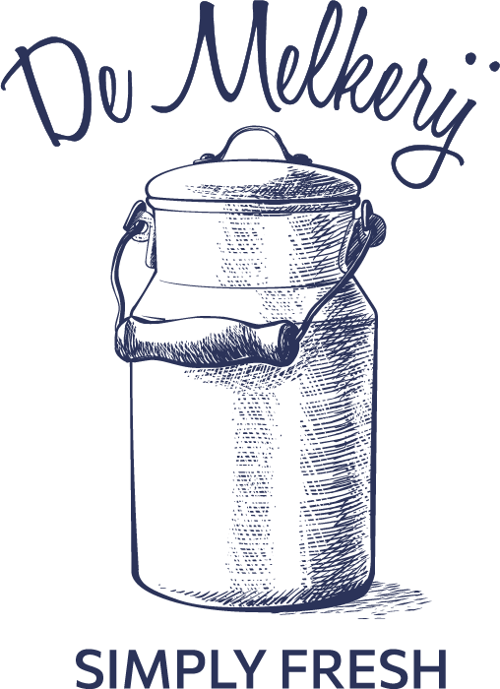

Standard Sanitary Operating Procedure (SSOP)
De Melkerij, Harlan, IA
712-579-6498

SSOP’s are written protocols that are specified in a food safety plan that define the procedures to be followed to achieve a specific goal or process. An SSOP may define temperatures, type of cleaning chemical, various steps, or other practices to be used, and in what order to achieve a clean bottle or bottle cap.

Milking Conditions

1. Assure De Melkerij Milking Procedures are followed.

2. Assure that milking equipment is clean and well maintained.

- All milking equipment is cleaned according to SSOP practice as described.

- Flush bucket milker with potable tepid water to break down calcium deposit buildup.

- Wash and scrub inside of bucket milker and other milking equipment (including bucket, lid, gasket, inflations, etc) with CIP cleaner. Then wash and scrub the outside of bucket with General Dairy Detergent. Rinse with hot water and sanitize.

- Inside of inflations are washed using a scrub brush and CIP cleaner. Inside of bucket is scrubbed as needed.

- Flush machine with hot water.

3. Machine is allowed to hang and drip dry in a protected area.

4. One time per week, machine is “deep cleaned”. Claw is disassembled and washed in all hard-to-reach places and ran through the sanitary cycle in the dishwasher. An Acid Rinse is used as the final rinse during this “deep clean.”

5. Any hoses, inflations and other parts that are worn are replaced as needed, at a minimum twice a year.

6. The vacuum lines are cleaned periodically to minimize any potential for contamination.

7. Ensure that each time you enter the milk processing room you wash hands before continuing with your task.

Bottling Conditions

- Ensure that glass bottles are clean and sanitary prior to filling with milk.

- All glass bottles are initially cleaned by herd-share members and then inspected and washed again on the sanitary cycle in the dishwasher on the farm. They are rinsed with a sanitary solution prior to filling.

- Glass jars are kept sanitary by being stored upside down on a clean tea towel in a protected room. Allowing them to air dry without being contaminated.
- All personnel who handle glass jars wash their hands first. The dishwasher wears rubber gloves when handling jars.

- Label jars and write name and date on each jar.

- Once milk is chilled in the bulk cooling tank jars are filled and labeled and placed in refrigerator. Assure thermometer is at 34-38 degrees Fahrenheit when you open the fridge.
- Record volume of milk.

- Jars remain in the refrigerator for that morning until member arrives to pick up their share of the milk produced for that week.

Processing Room Set-Up:

- Enter the milk processing room, close the door behind to keep out flies, and wash hands before handling any equipment.

- Prepare PREE dairy chlorinated solution in designated 5-gallon bucket. Dip all removeable parts of the milker in the solution and place on drying rack to drip dry. Assemble bucket milker and rinse with PREE from 5-gallon bucket. When pouring the solution out of the milker make sure it touches all sides. Allow milker to drip dry on clean towel.

- Prepare bulk cooling tank.

Cow Preparation and Staging:

- Bring cows into outside holding pen. Inspect cows for cleanliness and general health. Use brush to clean dry debris from cows’ flanks, legs, and udders prior to entering the milking parlor.

Milking Parlor:

- Prepare feed for each cow in the designated stanchion bins: Current grain and supplement ration will be posted in feed preparation room.

- Prepare udder wash solution in bucket and add rags. Clean, dry rags are in the designated bucket on the counter in the Milk Parlor.

- Retrieve bucket milker from Processing Room and place on counter in the Milk Parlor.

- Retrieve small bucket with rags and warm soapy water and the metal tray (which will be used to place the milker on while milking)

Udder Preparation

- Bring cow into the milking parlor. If cow’s hooves track in debris, gently sweep away to make sure that the floor under the udder is clear of bedding, mud, or manure.

- Inspect udder for visible presence of manure. Using water and a couple drops of “Basic H organic cleaner” mixed together in the designated bucket, clean each teat using a corner of the wet rag for each teat. If necessary, use another wet clean rag to wash the udder. Dirty rag is then placed in dirty-rag bucket.

- Dip dry teats with iodine-based teat dip. Allow teat dip solution to stay on teats for a minimum of 30 seconds.

- Place bucket milker next to the cow on the designated metal tray and connect vacuum pump hose.

- Wipe teat dip off with a clean rag, using a clean side for each teat or a new rag.

- Before stripping milk ensure hands are clean by washing them while teat dip is on the teats.

- Squeeze out the first 5 squirts from teats on to the black mat and inspect for problems. Perform CMT if mastitis signs are present.

- Start vacuum and turn on until it pulsates.

- Place inflations onto each teat ensuring they do not touch ground.

- Stay attentive during entire milking process to ensure that claw does not fall off.

- Release each teat cup from teat as the quarter is done being milked. Ensure claw does not touch the ground.

When cow is done:

- Remove bucket from the tray and place in the milk room.
- While the cow is finishing her feed, wash hands and pour the milk carefully through the strainer into the bulk cooling tank.
- Inspect filter.

- Strip each quarter by hand to ensure total emptying.

- Dip each teat in post dip solution to disinfect and seal teat orifice.

- Release cow back to pasture.

- Bring in next cow following the above process.

- Before starting the cleaning process wash hands

Clean Machine:

TEPID water is used to flush milk residues prior to flush with hot water and other sanitizers and soaps etc.

- Place one 5-gallon bucket in each sink. One in the “tepid” sink and one in the “clean” sink. Fill the TEPID bucket with TEPID water. Fill the bucket in the “clean” sink with hot water and add SOLUTION (CIP Detergent).
- In another small bucket add General Dairy Detergent, hot water and a clean rag.
- Rinse outside of claw with tepid water from any visible debris
- Place rinsed claw in TEPID bucket of water.
- Connect vacuum hose and allow the machine to pump the water through the machine to break down calcium deposit buildup.
- Place rinsed claw in the bucket with hot water and SOLUTION.
- Remove lid from bucket milker and dispose of the TEPID water.
- Use the rag from the small bucket with General Dairy Detergent to manually wash the inside of the lid. Remove the rubber gasket and wash it. Then wash the opening of the bucket milker.
- Replace cleaned gasket in the lid, rinse with HOT water and place back on the bucket milker.
- Connect vacuum hose and allow the machine to pump the HOT CIP water through the machine.
- Empty “clean” bucket of any remaining liquid and fill with HOT water
- Place claw in HOT water
- Remove lid and dispose of HOT CIP water ensuring to touch all sides of bucket with the HOT water while doing so.
- Replace lid and rinse the bucket.
- Connect vacuum hose and allow the machine to pump the HOT water through the machine.
- Remove lid and dispose of HOT water ensuring to touch all sides of bucket with the HOT water while doing so.
- Place claw in in PREE dairy chlorinated solution in designated 5-gallon.
- Replace lid.
- Connect vacuum hose and allow the machine to pump the PREE dairy chlorinated solution water through the machine.
- Remove lid and dispose of PREE dairy chlorinated solution water ensuring to touch all sides of bucket with the solution while doing so.
- Remove lid and hoses
- Hang claw parts and hoses and bucket to dry.

- One-two times per week, machine is “deep cleaned” by disassembling the entire system and washed in all hard-to-reach places. The lid and pulsator are disassembled and washed in all hard to reach places. Then they are soaked in a dairy acid rinse.

- Dirty rags are placed in designated bucket with bleach water to soak prior to being brought to house for washing.

Clean Bulk Cooling Tank
- The bulk cooling tank is emptied and cleaned once every 24 hours. Only combine 2 milkings (evening and morning)
- After morning milking is chilled to proper temperature, fill bottles and empty tank completely
- Place 5-gallon bucket under spout
- In the sink prepare 2 5-gallon buckets. One with TEPID water and one with hot water. Additionally prepare a small bucket with hot water and General Dairy Detergent
- Rinse bulk tank with the TEPID water to include the agitator
- Close the valve
- Use General Dairy Detergent and the designated yellow scrub brush to scrub the inside of the bulk tank to include the agitator
- With the hot water rinse the agitator and the sides of the bulk cooling tank
- Remove the fill spout and the fill spout adaptor (but leave the valve attachment) and place in small bucket with hot soapy water
- Place the designated white large bottle brush in the opening of the bulk cooling tank.
- Open the valve while at the same time using the bottle brush to scrub the opening ensure the soapy water rinses the opening while brushing
- Then remove the valve attachment and place in small bucket with hot soapy water
- Complete rinsing the inside of the bulk cooling tank with hot water
- Rinse the inside of the bulk cooling tank and the agitator with PREE solution and allow to drip dry
- Use the small white bottle brush to scrub each of the bulk tank spout attachments and valve that were placed in the small bucket with hot soapy water
- Rinse them with hot water
- Then rinse them with PREE solution and attach back to the bulk tank
- Close the lid
- Use the designated bleach spray bottle and a clean rag to clean only the OUTSIDE of the bulk cooling tank
- Once a week do an acid soak on the bulk cooling tank and all its parts
- Once a week run all removeable parts through the sanitary cycle on the dishwasher
- Sweep floor and vacuum when necessary.

Cleaning Milk Processing Room & Milking Parlor

- Sanitize counters/filter/sinks in milk room using bleach solution spray.

- Sweep floor and vacuum when necessary.

- Milk processing room door is to remain closed.

- Cleaning milking parlor –Sweep to remove manure and wash down with pressure washer when needed.

  - Sanitize counter space

